MCKAY MCKINNON CRANIOFACIAL TUMOR WORKS IN VIETNAM
https://www.google.ca/search?q=Dr.+McKay+McKinnon+Tumor+Mission+Report&rlz=2C1EODB_enCA0537CA0537&oq=Dr.+McKay+McKinnon+Tumor+Mission+Report&aqs=chrome..69i57j69i65&sourceid=chrome&ie=UTF-8
http://vinacapitalfoundation.org/dr-mckay-mckinnon-tumor-mission-report/
You are here: VinaCapitalFoundation » Dr. McKay McKinnon Tumor Mission Report

Dr. McKay McKinnon Tumor Mission Report
AUGUST 16, 2013 BY VINACAPITAL FOUNDATION

The last two weeks were filled with miracles for 12 patients suffering with horrible tumors.
[ultimate-photo source=”flickr” type=”set” set=”72157635464176267″ uid=”101282118@N07″ size=”640″ style=”slideshow” num=”20″ slideshow_style=”1″ fixed_height=”1″ align=”center” disable_link=”1″ ]
The joy of helping these children and young adults is really amazing. To imagine how horrific their life has been like until now and then to think about what a difference we have made makes our hearts sing.
The mission was possible because of the generosity of Dr. McKay McKinnon and his wife Astrid who gave two weeks of their time away from their plastic surgery practice in Chicago to help patients in Vietnam.
Dr. McKay did some marathon surgeries and even operated on Saturday the 3rd when he was flying out that night. He will return soon to help with followup surgeries and teach again. I would like to share some stories from the July 22-August 4 Tumor Surgery Mission:
Nguyen Hoang Thien An – Surgery at FV Hospital
This young lady made a strong impression on me when I visited her before the surgery. She was strong and confident and very excited about the surgery. When I heard that she had managed to be top in her class in school, and had just sat for the college entrance exam I knew by impression was right. I want to be involved with this girl for a long time. She has very special qualities that need nurturing. She will need one or two more surgeries.
Her goal is to become a pharmacist and she has taken the entrance exam for two pharmacy schools. VCF will do all we can to help her realize this dream.
Le Hoang Em – Surgery at FV Hospital
Hoang Em is also special. Despite the growth that has plagued him since he was a baby, Em has an amazing attitude and everyone has shown him love in his village where he tends ducks and sells duck eggs.
Em has a girlfriend and said he wanted to have the surgery so he could be more handsome so he could get married. We are so excited about this! He told our program coordinator Tran Quoc Thanh to tell Dr. McKinnon that he can close his eye when he sleeps now as Dr. Mckinnon promised him! Em will need one or two more surgeries.
Le Trung Tuan – Surgery at VINMEC Hospital
Mercy this child, 13 years, whose tumor started in 2009 has just had a serious life change.
The tumor was life threatening and the surgery very difficult, but Dr. McKinnon was joined by a Neuro surgeon Tran Van Sy from National Hospital of Pediatric and Dr. Nguyen Thanh Liem from Vinmec hospital in this surgery which took 9 hours.
During the next surgery, Dr. McKinnon will build Tuan a nose and move his eyes to the right place among other issues. This child is so thin that we will be supporting the family with extra nutritional support to build him up.
Dang Thanh Binh – Surgery at Children’s Hospital Number 2
This little three- year- old was one of the cutest little ones I have seen in a long time. Despite his deformities, he has a fun and sweet spirit. This surgery took tumors from chest and buttocks on one side. Dr. McKinnon will remove tumors from the other side during the next surgery. Great news and evidence of the capacity building side of this mission is that a girl has been admitted to Children’s Hospital II with the same type of tumor on the buttocks and leg, and the CH2 team will do the surgery!
Kieu Thi My Dung – Surgery at Cho Ray Hospital
Dr. McKinnon did the first surgery for My Dung, a 24 year old young woman from Lam Dong last year, and this year he did a followup surgery to remove the remaining tumor tissue, take tumors off of her next and ear, moved her ear back up to the right place, and open her eye. What an amazing relief for her not to have those horrible masses hanging from her!
Surgeries performed at Viet Duc Hospital in Hanoi
These children were operated on at Viet Duc hospital with Dr. Ha and Dr. McKinnon as main surgeons. In addition, Dr. McKinnon presided over a major clinic of 40 tumor patients and spent time teaching the local step by step approach they could use to do the cases themselves. Dr. McKinnon did this at every hospital.
In addition to the support for logistics and costs of the surgical tumor mission, VCF Capacity Building Team arranged for broadcast of all the surgeries into a classroom or auditorium and invited hundreds of local surgeons could watch and listen to the surgeries with Dr. McKinnon teaching. Over 40 surgeons attended these broadcasts in Hanoi and HCM. One doctor commented “that’s a great idea to broadcast the operation and we also want to do surgery with Dr MM at UMC in near future“. VCF also recorded the broadcasts and will distribute to surgeons for their review and continued learning.
Le Thanh Vu – Surgery done at Cho Ray
This bright young man with a sunny disposition and warm smile sells lottery tickets. Cho Ray had already removed one of his back tumors and will continue to help him. Dr. McKinnon did a marathon 9 hour surgery to remove the draping tumors hanging from his arm which weighed about 3.5 kgs and kept him from using that arm at all. We will do our best to help him through his recovery period and support some physical therapy to help rebuild that arm to good use and then hope that we can use our contacts to find him a better job.
Future Surgeries- Ongoing Treatment
Le Nguyen Cao Truc and Tran Hai Quan will be receiving a series of treatments at Children’s Number II until Dr. McKinnon returns.
Cao Truc who is in serious danger from his humongous tumors is simply too small and weak to endure a major surgery. Dr. McKinnon prescribed tests on his heart to assess heart failure and treatment. VCF hopes to be helping with super nutritional supplements and physical therapy for Cao Truc to build him up so that he can withstand the surgery. If his tumor had been removed when it was smaller, he could have been cured. Now there is only a slim chance that we can help him, but we are not giving up.
Tran Hai Quan is a precious, precocious and lively 3 year old who has already had 6 surgeries and many procedures. He wears a feeding tube for nutrition and has a tracheotomy for breathing. Dr. McKinnon suggested a workup by the Ear Nose and Throat Specialist to see if he is a candidate to cap the tracheotomy during the day which would enable him to learn to speak. Children’s II will also be doing regular injections through the mouth under anesthesia of a tumor reduction drug Bleomycin. Dr. McKinnon says his tumor will stop growing by age 5 and that is the time to do the final surgeries. VCF will be supporting the Bleomycin treatments and speech therapy until the next surgery.
Donors
None of this wonderful work could happen without the generous donors with a heart for these children that made this tumor mission possible:
Corporate & NGO Donors
- Detech Foundation in Hanoi
- Vinmec Hospital in Hanoi
- Movenpick Hotel in Hanoi
- Vovicare in Sydney Australia
- Children’s First in Melbourne Australia
- FV Hospital in Phu My Hung, Ho Chi Minh City
- Children’s Number II, in Ho Chi Minh City
- Cho Ray Hospital in Ho Chi Minh City
- Dai Phuoc Lotus Real Estate Development in Dong Nai
Individual Donors
- Tran My Ha
- Mike Gammel
- Le Minh Phuc
- Phan Thi Lan
- Tran Van Cuong
- Nguyen Thi Hanh Le
- Tran Thanh Hai
- Linh Phuong Bui
Dr. McKinnon and his wife are the biggest donors of all giving two weeks of their time and talent to help these young people and teach doctors in Vietnam how to help other patients. It is impossible to convey how we all feel about their dedication to helping others.
VCF also wants to thank Seiad Seyadoussane, better known by his email moniker Sam Ottawa, who through V2MN organization is a uber-dedicated advocate for difficult cases of all kinds who introduced us to the tumor kids and helped in many ways to make this mission possible. Many thanks also to Sam’s colleague Tina Nguyen, a fellow Canadian and owner of the Faifoo Hotel, for her dedication to helping the McKinnon’s with translation in Hanoi for a week, including inside the operating rooms!
This is an important ongoing effort for VCF, so please be in touch if you would like to get involved. There are too many of these children who need our help.
FILED UNDER: STORIES

http://vinacapitalfoundation.org/tumor-mission-report-2015/
You are here: VinaCapitalFoundation » Tumor Mission Report 2015

Tumor Mission Report 2015
JANUARY 6, 2016 BY VINACAPITAL FOUNDATION
Since 2012, VCF has begun to build capacity for surgery for tumors that plague children in Vietnam and has done 45 cases with complicated tumors, 120 doctors have been trained via live surgery and onsite lectures. In 2014 a leading international expert travelled to Vietnam on his third training mission teaching local surgeons by providing advice and guidance on ongoing cases as well as conducting teaching surgeries on 12 urgent and critical cases with local surgeons assisting. These operations were viewed by other surgeons from the region for teaching purposes and they were recorded and distributed to hospitals across Vietnam.
Different from previous years, the year of 2015 has welcomed Dr. McKay McKinnon and his wife Astrid back to Vietnam with two trips in Hanoi and HCMC. There were one week of March and one week of September that filled with miracles for 17 patients suffering with horrible tumors. To look at angel faces suffering from dangerous diseases made our hearts break and then to see the difference we have made makes our hearts smile.
We would like to share some stories from the two trips:
N.H.T.An (born in 1995)
Surgery at FV Hospital
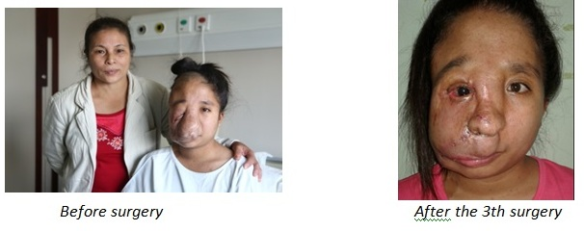
This was the third and final operation of this Pharmacology student. On the afternoon of 10th September 2015, Prof. McKinnon and FVH’s surgeon team continued to reconstruct her face to improve her facial appearance. This young lady now can be more confident and no longer has to hide herself at home. The tumor was first seen on the right side of her face when she was seven months. The tumor grew fast and gradually deflected her nose, eye and lips from their original position and deformed the right side of her face. We would like to help her continue with higher schooling at the HCMC University of Medicine and Pharmacy after she finishes her classes at Nguyen Tat Thanh school.
K.T.M.Dung (born in 1989)
Surgery at FV Hospital
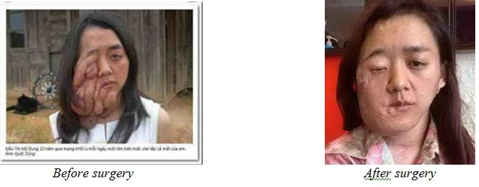
Dung, living in Da Lat, was born with a small tumor near her eyelids which made her face distorted 3 months later. The tumor grew and made her face appeared increasingly asymmetrical but her family could not afford the surgery to remove it. Prof. McKinnon conducted the first surgery to remove the tumor and reconstruct My Dung’s face in 2012 at Cho Ray. In 2013 and 2014, Dr. McKinnon performed other reconstructive surgeries on her face. The surgery performed in September 2015, Dr. McKinnon and FV’s surgeon team continued the reconstruction of Dung’s face. After surgery, Dung facial appearance was much improved, and her right eye, which was previously hidden by the tumor, was also retained.
N.T.N.Thi (born in 1988)
Surgery at FV Hospital
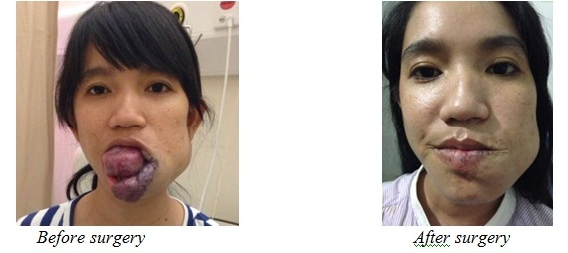
The efforts to live of this young garment worker Thi has made our hearts break. She had a blood tumor in her mouth and tongue at a very young age. Initially, the tumor was only around the size of a bean on her tongue. Along time, it gradually protruded outside and damaged her entire lower lip. It often bleeds and causes pain. Thi’s family took her to many hospitals but were always refused help as hers was a very difficult case. In September 2014, Prof. McKinnon, Dr. Nguyen Quang Dai and the FVH’s surgeon team performed a surgery to remove the tumor, partly cutting away the part of her tongue damaged by the tumor and reconstructed her lips and face. After this surgery, her facial appearance was much improved. Her tongue was placed in the correct position so that she could eat normally again. The second surgery was conducted on the morning of 11th September 2015, Prof. McKinnon and the surgeon team once again performed a reconstructive surgery for Thi.
T.T.M.Son (born in 1995)
Surgery at FV Hospital
Son’s legs were unusual from birth. As she grew up, her feet and toes became bigger and deformed, making her unable to walk. When Son was 10, she quit school as she felt insecure around her friends and suffered from constant pain. As her mother became older and could no longer carry Son on her back, Son had to move by dragging her legs along behind her body. On 10th September 2015, Dr.McKinnon and Dr. Vincent Blondeaux gave Son a medical examination. After the consultation, they decided to start the surgery by finding out which nerve from which the tumor had originally grown to prevent it from further development and removed the growing tumors on Son’s legs. Son is still in FV after operation one month as her wound does not close well yet, she may have to stay in the hospital for some time until the wound is in safe condition to discharge. Dr Vincent Blondeaux will perform secondary debridement of skin and soft tissue lesion for Son to help improving the healing process.
L.T.Tuan (born in 1998)
Surgery at VINMEC Hospital
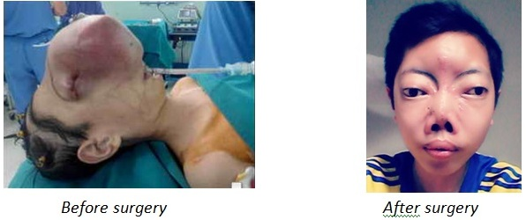
Tuan’s tumor started in 2009 which made his life change seriously. The first surgery conducted in 2013 by Dr. McKinnon, Neuro surgeon Nguyen Van Sy from NHP and Dr. Nguyen Thanh Liem at Vinmec which took 9 hours. After surgery, he returned to school in September 2013 after 4 years out of school and started with the 6th grade. He loved to go to school rather than learning with a tutor because with that way, he could make friends with others. His father said he liked to ride bicycle and usually ride 2-4 kilometers everyday. VCF gave him a laptop as a Christmas gift in 2013 and he usually used it to write emails to us to inform his health and schooling situation. The third time performed as a reconstructive surgery was done in March 2015 by Dr. McKinnon and Dr. Nguyen Thanh Liem was also a successful one.
Surgeries at Viet Duc Hospital (23-26 March 2015)
These patients were operated on at Viet Duc hospital with Dr. Ha and Dr. McKinnon as main surgeons. In addition, Dr. McKinnon presided over a major clinic of more than 30 tumor patients in the morning of 23 March and spent time teaching the 15 local doctors step by step approach they could use to do the cases themselves.
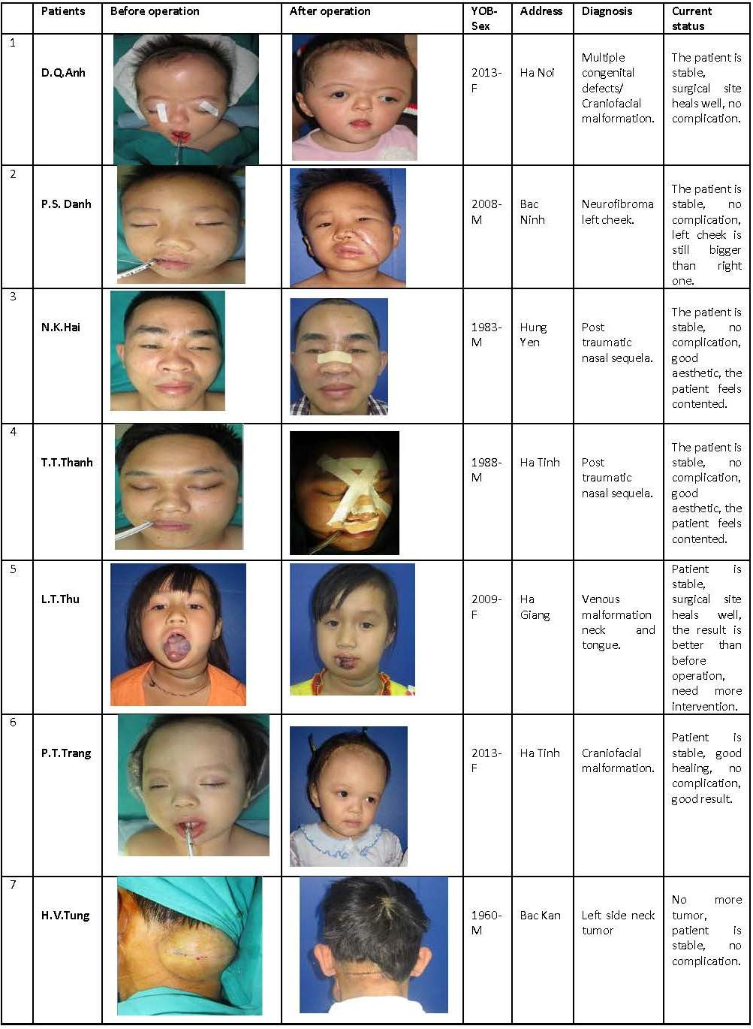
Surgeries at HCMC University Medical Center (7-9 September 2015)
VCF Capacity Building Team arranged for broadcast of all the surgeries into a classroom and invited local surgeons to watch and listen to the surgeries with Dr. McKinnon teaching. One doctor, after joining the broadcast at Children Hospital #2 in 2014, commented “that’s a great idea to broadcast the operation and we also want to do surgeries with Dr McKinnon at UMC in near future.“ Coming from this comment, VCF set up meetings with Dr Nguyen Anh Tuan, Head of Plastic and Cosmetic Surgery Department (UMC), and started a cooperation with UMC since September 2015.
By the first cooperation on Tumor Mission with UMC, we had welcomed 65 doctors to the training course on maxillo-facial reconstructive surgery conducted by Prof. Mckay Mckinnon in the morning of September 7 then Dr Mckay and Dr Tuan’s team examined and consulted for 20 patients in the afternoon same day. All doctors could see and listen to the consultation of Dr Mckay and patients through live broadcasting from the clinic to the class room. After 3 days of training with lectures and live surgeries, all doctors were certificated by the UMC.
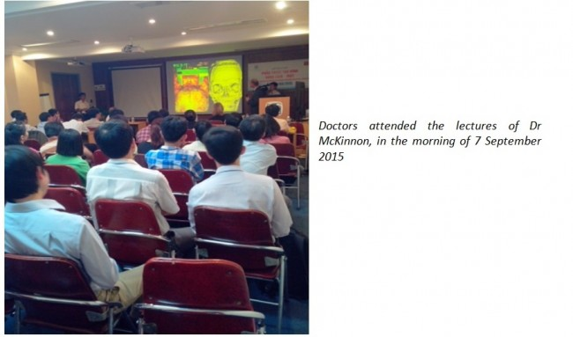
There were 5 surgeries at UMC in 2 days 8 – 9 September

Besides Tumor Mission, VinaCapital Foundation has also worked with FV Hospital on Disabilities since 2014. Patient Nguyen Mai Linh Lan was born in 2012 with congenital malformation in both hands, club left hand without radius, only four fingers, lack of thumb and right hand with floating thumb. Baby Lan is living in a poor family of 20 members, her mother is a sewing worker and father is unemployed. The first surgery was done on 21 November 2014 by Dr. Stephan Guero – Hand Surgeon at FVH to transfer tendon, implantation of fixator on left wrist. This year, VCF agreed with FVH to share the cost to cover the 2nd step on hand surgery on March 2015 for this little girl with Dr. Stephan Guero. Dr. Guero will come back to work at FVH from November 16th – November 27th 2015 and he is going to perform Policization of a complete finger on right hand for the girl at FVH.
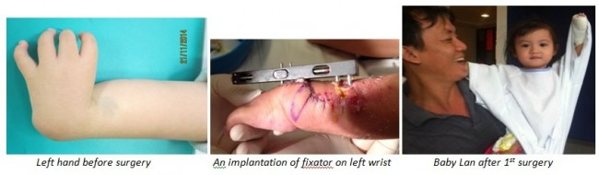
Thank-you letters
Son wrote to Sam “My family would really like to say thank to you, VinaCapital Foundation and FVH team for help and support for the operation at FVH. I am very lucky to be treated at FVH, everyone is enthusiastic and very kind in caring for me. Can you give my big thanks to Dr. and Mrs. McKinnon, Ms Tra My and VinaCapital Foundation who accompanied with me and my family on this operation.
Tuan wrote to Robin after his third operation “I would like to inform to you that I am totally in good health after operation one month, have gained weights, and returned to school. Thank you and VCF staff going together with me during 3 surgeries. I am attaching some recent photos for you to see how my face has been improved after 3 surgeries. Thank you again for your kind donation and I hope my good result in school may be a small reward to your kindness.”
“I am Ngoc Thi, one of the patients operated by Dr McKinnon and doctors at FVH. My operation has been a successful one, this time the orthopedic and reconstruction should be less painful than the first operation. I inform to you to share the happiness with me. My family would like to thank you and VCF and other donors very much for your kind contribution on my surgery so that I can have a brighter future. I will try to work in order to feed myself, to help the family and society, in order not to waste the effort of all who have helped me,” quoted from an email Ngoc Thi sent to VCF staff.
“I am Nga, Kim Hien’s father. I am writing this letter on behalf of our family and Hien to sincerely thank VCF, the American doctor, the doctors of UMC and all the donors. My family is very lucky to have the help from all of you for a successful operation that even in my family’s dream we did not dare to think about the magic that came to our daughter. I do not know what I should say to you, just write this letter to express our deep gratitude to all the donors. My family would like to wish to all of you good health and luck in life,” shared Kim Hien’s father.
None of this wonderful work could happen without the generous donors with a heart for these children that made this tumor mission possible:
Detech Foundation in Hanoi, Vinmec Hospital in Hanoi, Viet Duc Hospital, Sofitel Metropole Hanoi Hotel, Vovicare in Sydney Australia, Thoi Bao Community Fund, Children’s First in Melbourne Australia, FV Hospital in Ho Chi Minh City, University of Medical Center in Ho Chi Minh City, Caravelle Hotel Saigon, Dai Phuoc Lotus Real Estate Development in Dong Nai and the George Soros Foundation all gave very generously! In addition individual donors including Mr Viet Nguyen, Joshua Donfeld, Mike Gammel, Ms Do Thi Phuc Hien, Ms Linh Phuong Bui, Dr Tuong Van, Mrs Kim Tam, Mr & Mrs Hoa Minh Chau, Mr & Mrs Quang Nhan, Mrs Thanh Van gave personal donations straight from their heart!
VCF also wants to thank Sam Ottawa and his colleagues at V2MN organization who introduced us to the tumor kids and helped in many ways to make this mission possible.
There are too many other children who need our help. So please be in touch with us if you would like to get involved.
FILED UNDER: VCF PUBLICATIONS AND VIDEOS

